Reflective Portfolio Algebra 1



Unit 3: Linear Equations and Inequalities



At the conclusion of each unit, you will create at least two-page reflective study sheet.

## Section 1: Vocabulary (words/ or diagram: Define each of the following:

* Parameters of linear equation:
* Rate of change or slope and it’s formula:
* X and y intercepts:
* Half plane:



## Section 2: Formulas and Rules:

* What is the difference between the point-slope form of a linear equation and the slope intercept form?
* Vertical lines have what type of slope? __________________ Horizontal lines have _______________ Slope.

## Section 3: Key Methods and Concept:

1. Justify if the point (1, 4) is a solution for the following linear equation:
$$5y-15x=10$$

2. Identify the x-intercept and y-intercept for the above equation:

## Rearrange the following standard form into the slope-y-intercept form

$$5y-15x=10 \& 6y+ 4x-12=0$$

1. A climber is on a hike. After 2 hours he is at an altitude of 400 feet. After 6 hours, he is at an altitude of 700 feet. Let t represents the time it takes to climb in hours, and let a represents the number of feet that the hiker climbs. Calculate the average rate that represents this scenario. (hint: find the rate between (2,400) and (6,700)

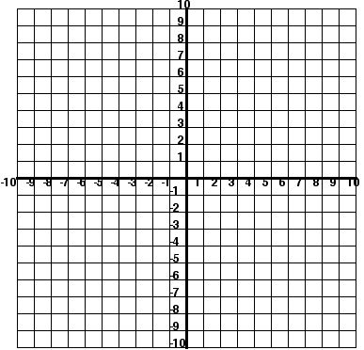

1. Identify the parameters for the following inequality, graph and shade half plane: pick one solution from the shaded region. $$-2y-6x≤8$$

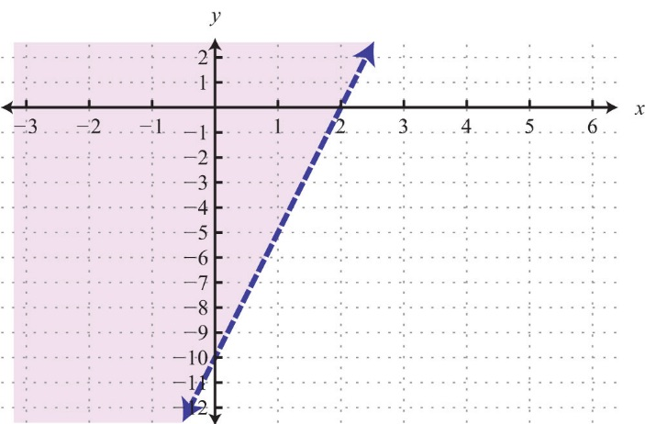

1. Write the linear inequality for the half plane:
2. If (*k*, 2) is a point on the graph of the equation 4*x* + 2 *y* = 4, what is the value of *k*?

8) Nicko is given $600 to spend on a vacation. He decides to spend $65 a day.

1. Write the linear equation that represents the relationship between the amount of money Nicko has in his account (y) and the number of days (x) of his vacation.
2. Identify the parameters, and what they mean in the context of the situation.